Login

SignUp

Dashboard

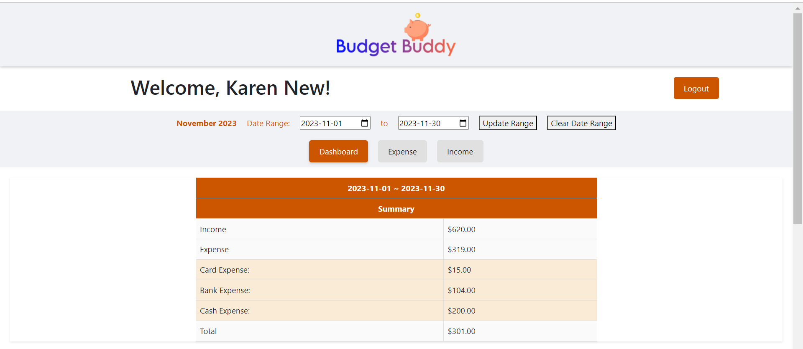

Expense tab

Income tab

